Activity 12
― Lesson 12

１．下の質問に英語で答えなさい。
２．グループになり，回答を発表し合い，最もよいと思われるものを選びなさい。

(You are at a beauty salon / barbershop.)
1. What would you do if the hairdresser cut your hair too short?
Your answer:

Best answer:

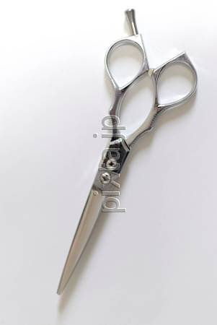



(You are in a classroom.)
2. What would you do if you lost your friend's notebook?
Your answer:

Best answer:

(You are at a movie theater.)
3. What would you do if you saw your boyfriend /
girlfriend with someone else?
Your answer:

Best answer:

(You win the lottery.)
4. What would you do if you got 1,000,000 yen?
Your answer:

Best answer:

